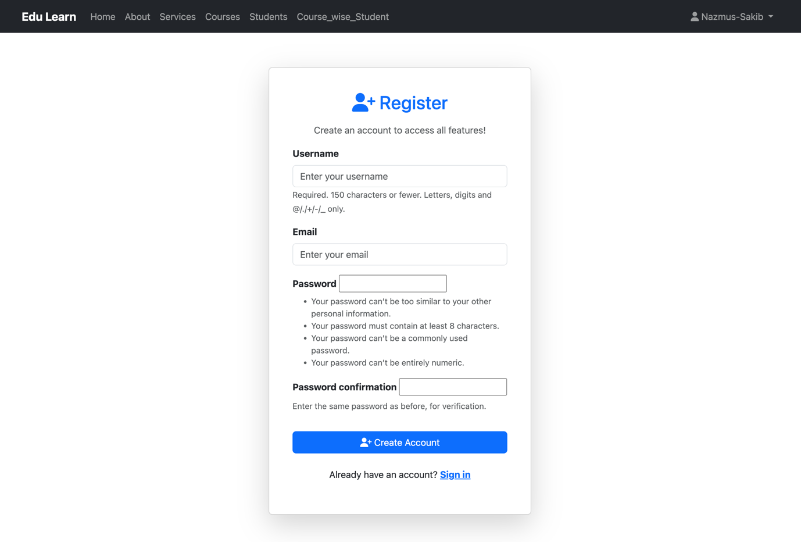
Screenshots

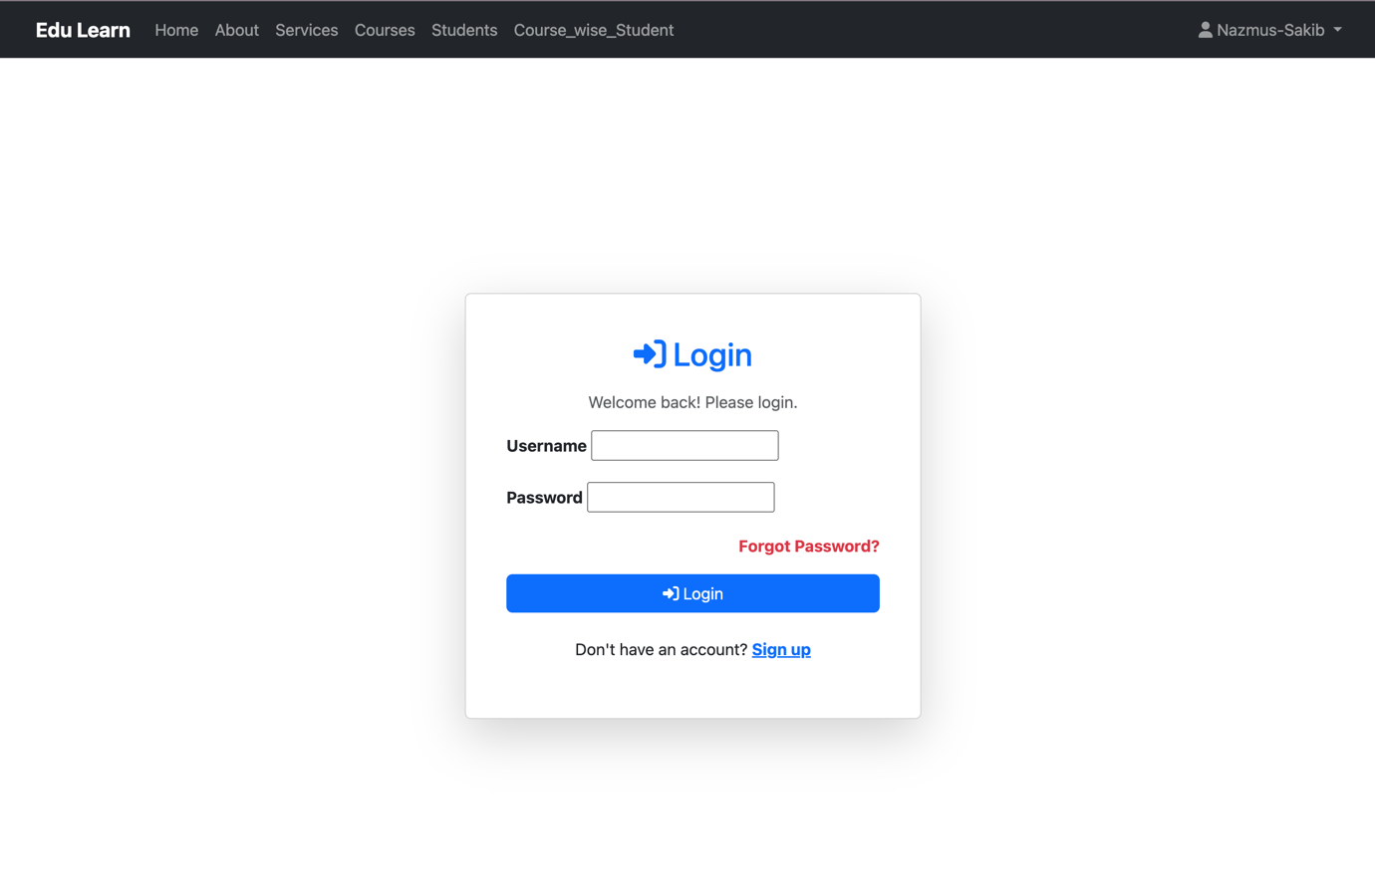

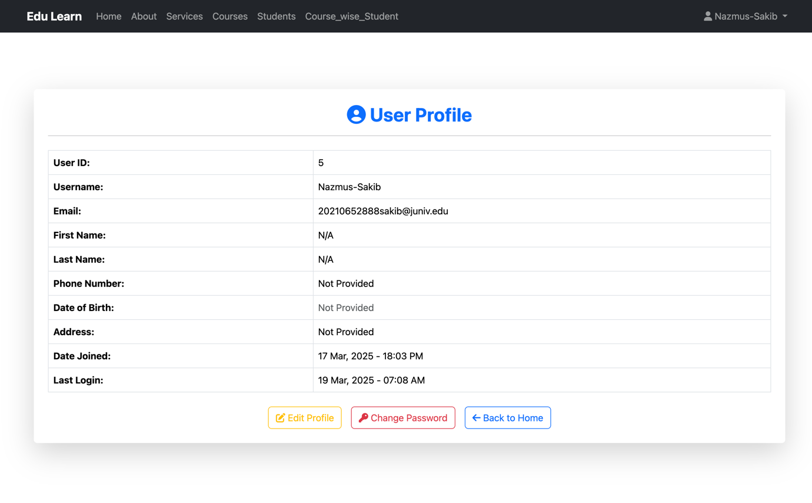

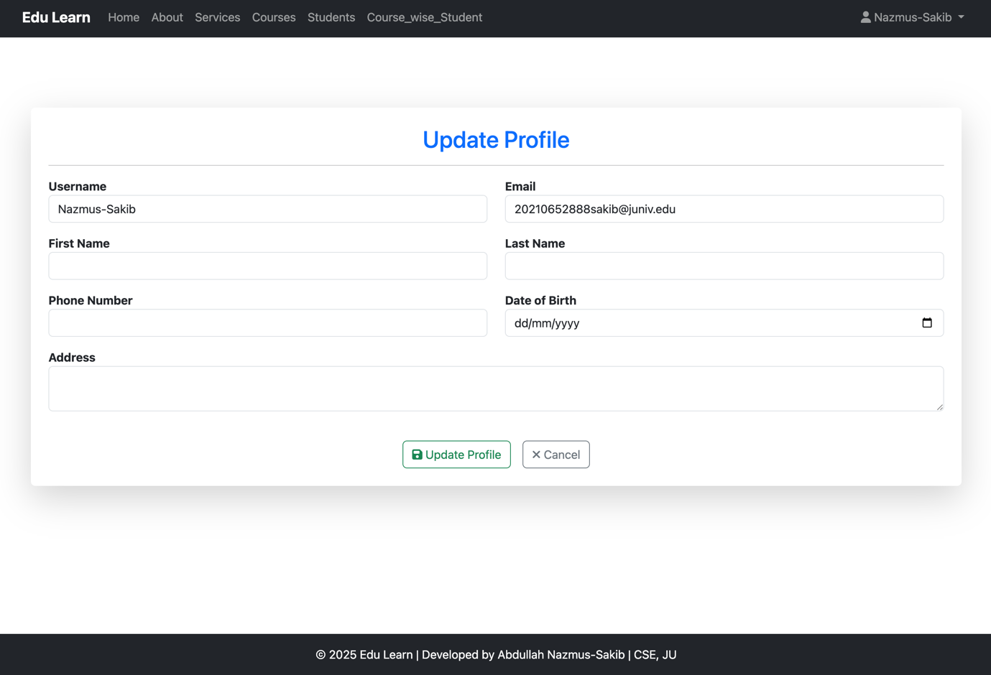

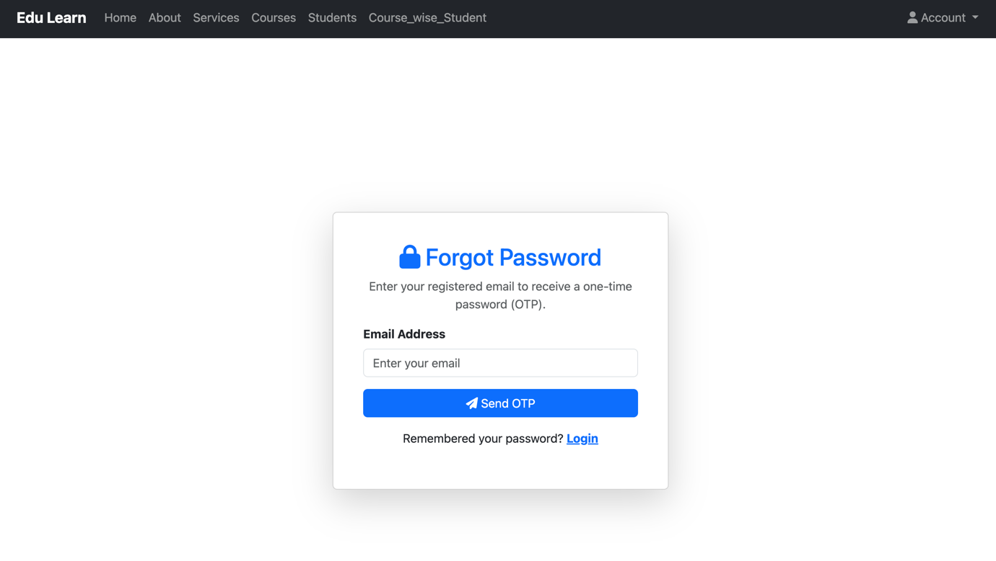

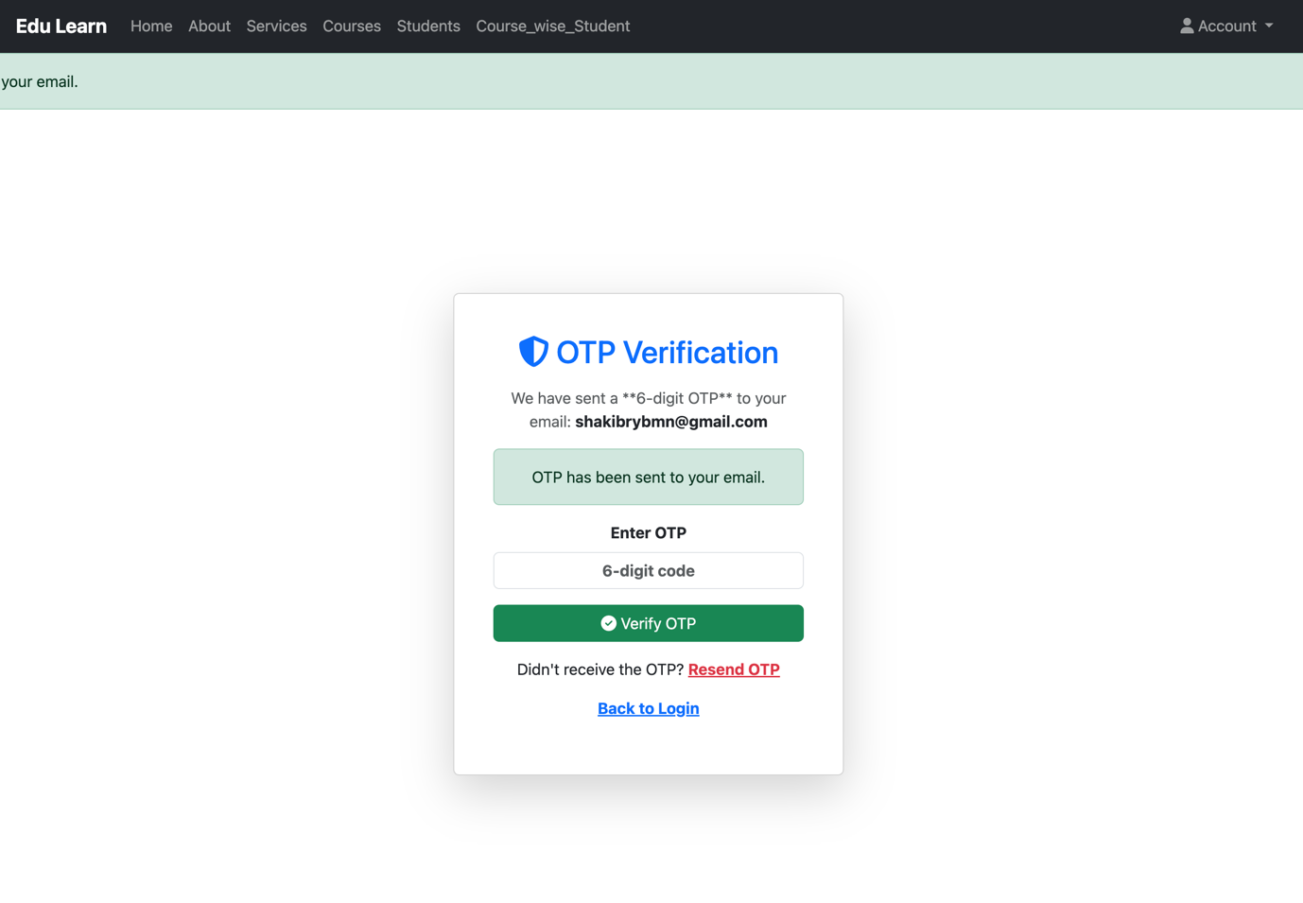

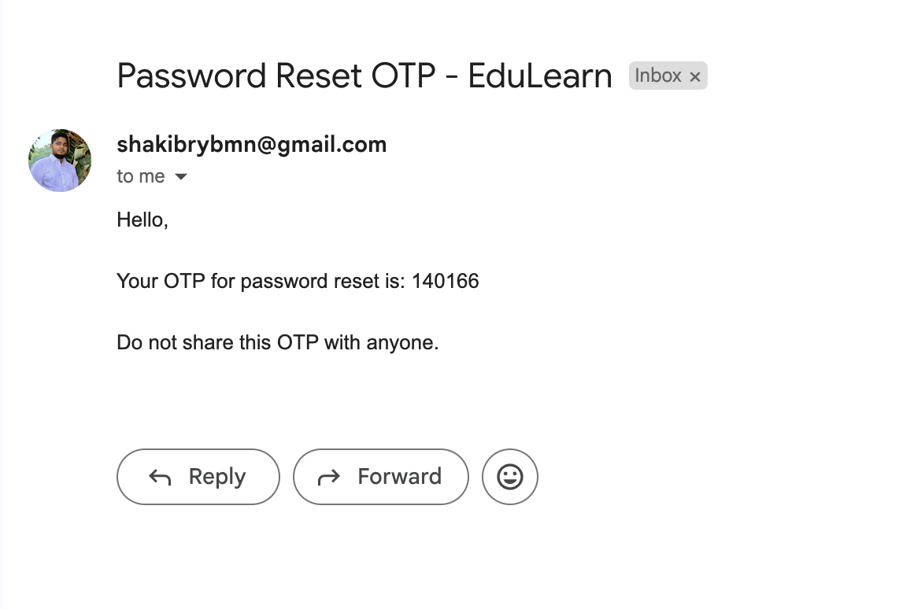

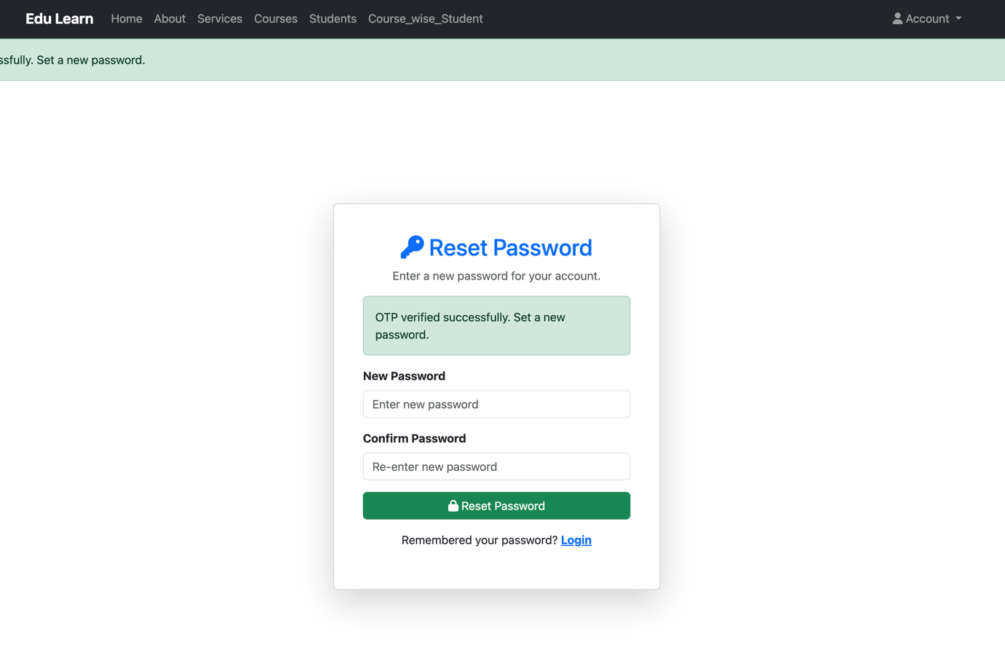

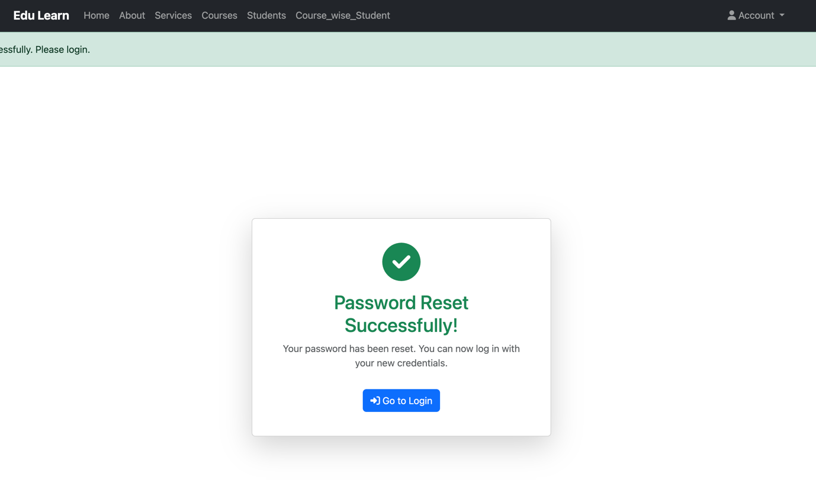

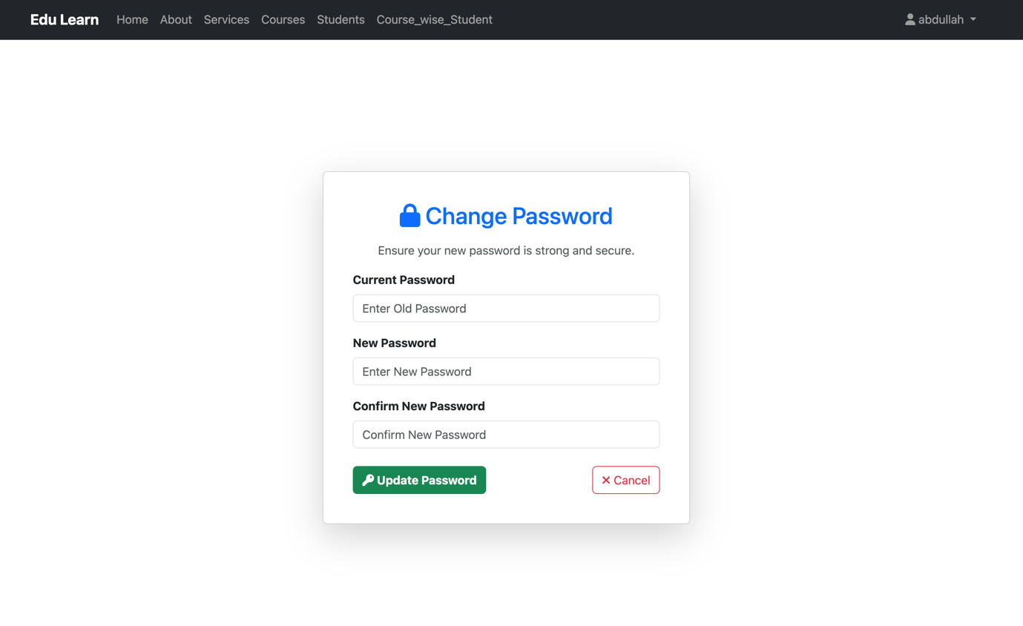

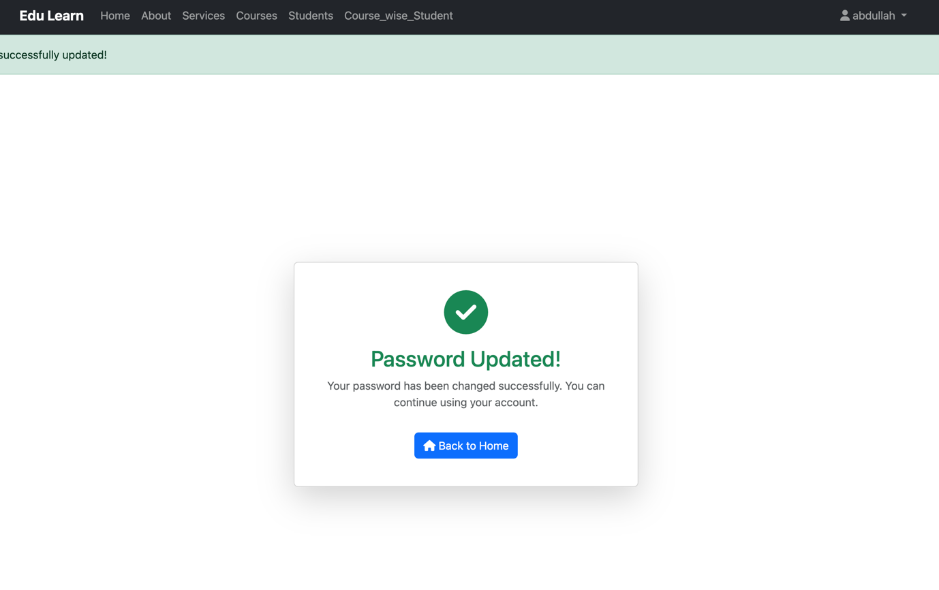

Views.py
from django.contrib import messages
from django.contrib.auth import authenticate, login, logout, update_session_auth_hash
from django.contrib.auth.decorators import login_required
from django.contrib.auth.forms import AuthenticationForm
from django.shortcuts import get_object_or_404, redirect, render
from .forms import CourseForm, LessonForm, StudentForm, UserRegistrationForm, UserUpdateForm, UserPasswordChangeForm
from .models import Course, Lesson, Student

# for sending mail to get otp
import random
from django.contrib.auth.models import User
from django.core.mail import send_mail
from django.conf import settings
from .forms import PasswordResetRequestForm
from django.contrib.auth.hashers import make_password

# html_path_variabl
html_path_delete_confirmation_form = "Course_app/delete_confirmation_form.html"
html_path_for_student_list="Course_app/student_list.html"
html_path_for_input_and_update="Course_app/input_and_update_form.html"

# Create your views here.
@login_required(login_url='login_user')
def course_list(request):
courses = Course.objects.all()

return render(request,"Course_app/course_list.html",{"courses":courses})

@login_required(login_url='login_user')
def Course_Details(request,id):
course = get_object_or_404(Course, id=id)
lessons = course.lessons.all()
context ={
'course':course,
'lessons':lessons
}

return render(request,"Course_app/Course_details.html",context)

@login_required(login_url='login_user')
def create_course(request):
form = CourseForm() # ✅ Initialize the form once

if request.method == "POST":
form = CourseForm(request.POST, request.FILES) # ✅ Correct form initialization
if form.is_valid(): # ✅ Moved inside the POST check
form.save()
messages.success(request, "Course added successfully!")
return redirect('course_list') # ✅ Ensure 'course_list' is defined in `urls.py`
context = {
'check' : 2,
'form': form
}

return render(request, html_path_for_input_and_update, context) # ✅ Pass the correct form

@login_required(login_url='login_user')
def course_edit(request, id):
course = get_object_or_404(Course, id=id) # Fetch the course object

if request.method == "POST":
form = CourseForm(request.POST, request.FILES, instance=course)
if form.is_valid():
form.save()
messages.success(request, "Course details updated successfully! ✅")
return redirect('course_list') # Redirect after successful update
else:
form = CourseForm(instance=course) # Pre-fill form with course details

context = {
'check' : 1,
'course': course,
'form': form
}
return render(request, html_path_for_input_and_update, context)

@login_required(login_url='login_user')
def course_delete(request,id):
course = get_object_or_404(Course,id=id)
if request.method == "POST":
course.delete()
messages.warning(request,"Course Successfully deleted!")
return redirect('course_list')
context = {
'course' : course,
'check' : 2
}
return render(request,html_path_delete_confirmation_form,context)

@login_required(login_url='login_user')
def create_lesson(request):
form = LessonForm()
if request.method == "POST":
form = LessonForm(request.POST,request.FILES)
if form.is_valid():
form.save()
messages.success(request,"Lesson added Successfully")
return redirect('course_list')
context = {
'check': 3,
'form':form
}
return render(request,html_path_for_input_and_update,context)

@login_required(login_url='login_user')
def lesson_edit(request,id):
lesson = get_object_or_404(Lesson,id=id)
form = LessonForm(instance=lesson)
if request.method == "POST":
form = LessonForm(request.POST,request.FILES,instance=lesson)
if form.is_valid():
form.save()
messages.success(request,"Lesson update Successfully")
return redirect('course_list')
else:
messages.error(request,"Lesson can't update Successfully")
context = {
'check' : 4,
'form' : form
}
return render(request,html_path_for_input_and_update,context)

@login_required(login_url='login_user')
def lesson_delete(request,id):
lesson = get_object_or_404(Lesson, id = id)
if request.method == "POST":
lesson.delete()
messages.warning(request,"Lesson Successfully deleted")
return redirect('course_list')
context = {
'lesson' : lesson,
'check' : 1

}

return render(request,html_path_delete_confirmation_form,context)

@login_required(login_url='login_user')
def student_list(request):
students = Student.objects.all()
context = {
'check':1,
'students':students
}
return render(request,html_path_for_student_list,context)

@login_required(login_url='login_user')
def Enroll_student(request):
form = StudentForm()
if request.method == "POST":
form = StudentForm(request.POST,request.FILES)
if form.is_valid():
form.save()
messages.success(request,"Student Enrolled Successfully")
return redirect('course_list')
context = {
'check' : 5,
'form' : form
}
return render(request,html_path_for_input_and_update,context)

@login_required(login_url='login_user')
def update_student(request,id):
student = get_object_or_404(Student,id = id)
form = StudentForm(instance=student)
if request.method == "POST":
form = StudentForm(request.POST,request.FILES,instance=student)
if form.is_valid():
form.save()
messages.success(request,"Student Updated Successfully")
return redirect('course_list')
context = {
'check' : 6,
'form' : form
}
return render(request,html_path_for_input_and_update,context)

@login_required(login_url='login_user')
def delete_student(request,id):
student = get_object_or_404(Student,id = id)
if request.method == "POST":
student.delete()
messages.warning(request,"Student Deleted Successfully")
return redirect('student_list')
context = {
'check' : 3,
'student' : student
}
return render(request,html_path_delete_confirmation_form,context)

@login_required(login_url='login_user')
def individual_course_enrolled_student(request,id):
course = get_object_or_404(Course,id=id)
students = course.students.all()

context = {
'course':course,
'students':students,
'check':2
}

return render(request,html_path_for_student_list,context)

@login_required(login_url='login_user')
def Course_wise_Student(request):
courses = Course.objects.all()

context = {
'courses':courses
}
return render(request,"Course_app/Course_wise_Student.html",context)

@login_required(login_url='login_user')
def individual_student_detail(request,id):
student = get_object_or_404(Student,id=id)
context = {
'student':student,
'check':3
}
return render(request,html_path_for_student_list,context)

# Uder Authentication process
def login_user(request):
if request.method == "POST":
form = AuthenticationForm(request, request.POST)
if form.is_valid():
username = form.cleaned_data['username']
password = form.cleaned_data['password']
user = authenticate(request, username = username, password = password)
if user is not None:
login(request, user)
messages.success(request,f"Welcome {username}!")
return redirect('course_list')
else:
messages.error(request,"Invalid usename or password!")
else:
form = AuthenticationForm()
context = {
'check' : 2,
'form' : form,
}
return render(request,"Course_app/user_login_and_register_form.html",context)

@login_required(login_url='login_user')
def logout_user(request):
logout(request)
messages.info(request, "You have been Logout!")
return redirect('login_user')

def register_user(request):
if request.method == 'POST':
form = UserRegistrationForm(request.POST)
if form.is_valid():
form.save()
messages.success(request,"Account created Successfully")
return redirect('login_user')
else:
form = UserRegistrationForm()
context = {
'check' : 1,
'form':form
}

return render(request,"Course_app/user_login_and_register_form.html",context)

@login_required(login_url='login_user')
def user_profile(request):
return render(request, 'Course_app/user_profile.html')

@login_required(login_url='login_user')
def update_profile(request):
user = request.user
if request.method == "POST":
form = UserUpdateForm(request.POST, instance=user)
if form.is_valid():
form.save()
messages.success(request, "Profile updated successfully!")
return redirect('user_profile')
else:
form = UserUpdateForm(instance=user)

return render(request, 'Course_app/update_profile.html', {'form': form})

def about(request):
return render(request,"Course_app/about.html")

def services(request):
return render(request,"Course_app/services.html")

# Forget password and reset section

# Dictionary to store OTPs temporarily
otp_storage = {}

def send_otp(email):
"""Generate and send OTP to the user's email."""
otp = random.randint(100000, 999999) # Generate 6-digit OTP
otp_storage[email] = otp # Store OTP temporarily

subject = "Password Reset OTP - EduLearn"
message = f"Hello,\\n\\nYour OTP for password reset is: {otp}\\n\\nDo not share this OTP with anyone."
from_email = settings.EMAIL_HOST_USER
recipient_list = [email]

send_mail(subject, message, from_email, recipient_list)

def request_password_reset(request):
"""Handle password reset request and send OTP."""
if request.method == "POST":
form = PasswordResetRequestForm(request.POST)
if form.is_valid():
email = form.cleaned_data['email']
user = User.objects.filter(email=email).first()

if user:
send_otp(email)
messages.success(request, "OTP has been sent to your email.")
return redirect('verify_otp', email=email) # Redirect to OTP verification
else:
messages.error(request, "No user found with this email.")

else:
form = PasswordResetRequestForm()

return render(request, "Course_app/request_password_reset.html", {'form': form})

def verify_otp(request, email):
"""Verify the OTP entered by the user."""
if request.method == "POST":
entered_otp = request.POST.get("otp")

if otp_storage.get(email) and str(otp_storage[email]) == entered_otp:
del otp_storage[email] # Remove OTP after successful verification
messages.success(request, "OTP verified successfully. Set a new password.")
return redirect('reset_password', email=email)
else:
messages.error(request, "Invalid OTP. Please try again.")

return render(request, "Course_app/verify_otp.html", {'email': email})

def reset_password(request, email):
"""Allow the user to reset their password."""
if request.method == "POST":
new_password = request.POST.get("password")
confirm_password = request.POST.get("confirm_password")

if new_password == confirm_password:
user = User.objects.filter(email=email).first()
if user:
user.password = make_password(new_password) # Hash the password
user.save()
messages.success(request, "Password reset successfully. Please login.")
return render(request,'Course_app/password_reset_complete.html')
else:
messages.error(request, "User not found.")
else:
messages.error(request, "Passwords do not match. Try again.")

return render(request, "Course_app/reset_password.html", {'email': email})

@login_required(login_url='login_user')
def change_password(request):
if request.method == 'POST':
form = UserPasswordChangeForm(data=request.POST, user=request.user) # ✅ Corrected form initialization
if form.is_valid():
user = form.save()
update_session_auth_hash(request, user) # ✅ Keep user logged in
messages.success(request, "Your password was successfully updated!")
return redirect('password_change_complete') # ✅ Redirect instead of re-rendering
else:
form = UserPasswordChangeForm(user=request.user)

return render(request, 'Course_app/change_password.html', {'form': form})

def password_change_complete(request):
return render(request, 'Course_app/password_change_complete.html')

forms.py
from django import forms
from django.contrib.auth.models import User
from django.contrib.auth.forms import UserCreationForm, PasswordChangeForm

from .models import Course, Lesson, Student

class CourseForm(forms.ModelForm):
class Meta:
model = Course
fields = ['title', 'descriptions', 'durations', 'thumbnail'] # ✅ Fixed "durations" to "duration"
widgets = {
'title': forms.TextInput(attrs={'class': 'form-control'}),
'descriptions': forms.Textarea(attrs={'class': 'form-control'}),
'durations': forms.NumberInput(attrs={'class': 'form-control'}),
}

class LessonForm(forms.ModelForm):
class Meta:
model = Lesson
fields = ['course', 'title', 'content']
widgets = {
'course': forms.Select(attrs={'class': 'form-select'}), # ✅ Bootstrap uses `form-select`
'title': forms.TextInput(attrs={'class': 'form-control','placeholder':'Enter the title'}),
'content': forms.Textarea(attrs={'class': 'form-control', 'rows': 5, 'placeholder': 'Enter lesson content...'}),
}

class StudentForm(forms.ModelForm):
class Meta:
model = Student
fields = ['name', 'roll', 'email', 'enrolled_courses']
widgets = {
'name': forms.TextInput(attrs={'class': 'form-control'}),
'roll': forms.NumberInput(attrs={'class': 'form-control'}),
'email': forms.EmailInput(attrs={'class': 'form-control'}),
'enrolled_courses': forms.CheckboxSelectMultiple() # ✅ Removed class="form-control" (not needed)
}

class UserRegistrationForm(UserCreationForm):
email = forms.EmailField(
required=True,
widget=forms.EmailInput(attrs={'class': 'form-control ', 'placeholder': 'Enter your email'})
)
class Meta:
model = User
fields = ['username', 'email', 'password1', 'password2']

widgets = {
'username': forms.TextInput(attrs={'class': 'form-control', 'placeholder': 'Enter your username'}),
'password1': forms.PasswordInput(attrs={'class': 'form-control ', 'placeholder': 'Enter your password'}),
'password2': forms.PasswordInput(attrs={'class': 'form-control ', 'placeholder': 'Confirm your password'}),
}

class PasswordResetRequestForm(forms.Form):
email = forms.EmailField(
max_length=254,
required=True,
widget=forms.EmailInput(attrs={'class': 'form-control', 'placeholder': 'Enter your email'})
)

class UserUpdateForm(forms.ModelForm):
phone_number = forms.CharField(max_length=15, required=False, widget=forms.TextInput(attrs={'class': 'form-control'}))
date_of_birth = forms.DateField(required=False, widget=forms.DateInput(attrs={'class': 'form-control', 'type': 'date'}))
address = forms.CharField(max_length=255, required=False, widget=forms.Textarea(attrs={'class': 'form-control', 'rows': 2}))

class Meta:
model = User
fields = ['username', 'email', 'first_name', 'last_name', 'phone_number', 'date_of_birth', 'address']
widgets = {
'username': forms.TextInput(attrs={'class': 'form-control'}),
'email': forms.EmailInput(attrs={'class': 'form-control'}),
'first_name': forms.TextInput(attrs={'class': 'form-control'}),
'last_name': forms.TextInput(attrs={'class': 'form-control'}),
}

class UserPasswordChangeForm(PasswordChangeForm):
old_password = forms.CharField(
widget=forms.PasswordInput(attrs={'class': 'form-control', 'placeholder': 'Enter Old Password'})
)
new_password1 = forms.CharField(
widget=forms.PasswordInput(attrs={'class': 'form-control', 'placeholder': 'Enter New Password'})
)
new_password2 = forms.CharField(
widget=forms.PasswordInput(attrs={'class': 'form-control', 'placeholder': 'Confirm New Password'})
)

urls.py
from django.contrib import admin
from django.urls import path
from Course_app import views

urlpatterns = [
path('',views.course_list,name='course_list'),
path('details/<int:id>/',views.Course_Details,name='coursedetails'),

path('create_course/',views.create_course,name='create_course'),
path('course_edit/<int:id>/',views.course_edit,name='course_edit'),
path('course_delete/<int:id>/',views.course_delete,name='course_delete'),

path('create_lesson/',views.create_lesson,name='create_lesson'),
path('lesson_edit/<int:id>/',views.lesson_edit,name='lesson_edit'),
path('lesson_delete/<int:id>/',views.lesson_delete,name='lesson_delete'),

path('student_list/',views.student_list,name='student_list'),
path('Enroll_student/',views.Enroll_student,name='Enroll_student'),
path('update_student/<int:id>/',views.update_student,name='update_student'),
path('delete_student/<int:id>/',views.delete_student,name='delete_student'),

path('individual_course_enrolled_student/<int:id>/',views.individual_course_enrolled_student,name='individual_course_enrolled_student'),
path('Course_wise_Student/',views.Course_wise_Student,name='Course_wise_Student'),
path('individual_student_detail/<int:id>/',views.individual_student_detail,name='individual_student_detail'),

path('login_user/',views.login_user,name='login_user'),
path('logout_user/',views.logout_user,name='logout_user'),
path('register_user/',views.register_user,name='register_user'),
path('profile/', views.user_profile, name='user_profile'),
path('update_profile/',views.update_profile,name='update_profile'),

path('about/',views.about,name='about'),
path('services/',views.services,name='services'),

path('forgot_password/', views.request_password_reset, name='forgot_password'),
path('verify_otp/<str:email>/', views.verify_otp, name='verify_otp'),
path('reset_password/<str:email>/', views.reset_password, name='reset_password'),
path('change_password', views.change_password, name='change_password'),
path('change_password', views.change_password, name='change_password'),
path('password_change_complete', views.password_change_complete, name='password_change_complete'),

]

base.html
<!-- base.html -->
<!DOCTYPE html>
<html lang="en">
<head>
<meta charset="UTF-8">
<meta name="viewport" content="width=device-width, initial-scale=1.0">
<title>{% block title %}Edu Learn{% endblock title %}</title>
{% load static %}

<!-- Bootstrap CSS -->
<link href="<https://cdn.jsdelivr.net/npm/bootstrap@5.3.3/dist/css/bootstrap.min.css>" rel="stylesheet">
{% comment %} static file link for this base html file {% endcomment %}
<link rel="stylesheet" href="{% static 'Course_app/css/base.css' %}">
<!-- Font Awesome for icons -->
<link rel="stylesheet" href="<https://cdnjs.cloudflare.com/ajax/libs/font-awesome/6.7.2/css/all.min.css>">

</head>
<body>
{% include 'Course_app/navbar.html' %}

{% if messages %}

{% for message in messages %}
<div class="alert alert-{{message.tags}}">{{message}}</div>

{% endfor %}

{% endif %}

<!-- Main Content -->
<div class="container my-5 content-wrapper">
{% block content %}{% endblock content %}
</div>

<!-- Footer -->
<footer class="bg-dark text-white text-center py-3">
<p class="mb-0">&copy; 2025 Edu Learn | Developed by Abdullah Nazmus-Sakib | CSE, JU</p>
</footer>

<!-- Bootstrap JS -->
<script src="<https://cdn.jsdelivr.net/npm/bootstrap@5.3.3/dist/js/bootstrap.bundle.min.js>"></script>
</body>
</html>

navbar.html
<!-- navbar.html -->
<nav class="navbar navbar-expand-lg navbar-dark bg-dark">
<div class="container">
<!-- Brand Logo -->
<a class="navbar-brand fw-bold" href="{% url 'course_list' %}">Edu Learn</a>

<!-- Navbar Toggler for Mobile -->
<button class="navbar-toggler" type="button" data-bs-toggle="collapse" data-bs-target="#navbarNav" aria-controls="navbarNav" aria-expanded="false" aria-label="Toggle navigation">
<span class="navbar-toggler-icon"></span>
</button>

<!-- Navbar Links -->
<div class="collapse navbar-collapse" id="navbarNav">
<ul class="navbar-nav me-auto">
<li class="nav-item">
<a class="nav-link {% if request.path == '/' %}active{% endif %}" href="{% url 'course_list' %}">Home</a>
</li>
<li class="nav-item">
<a class="nav-link" href="{% url 'about' %}">About</a>
</li>
<li class="nav-item">
<a class="nav-link" href="{% url 'services' %}">Services</a>
</li>
<li class="nav-item">
<a class="nav-link" href="{% url 'course_list' %}">Courses</a>
</li>
<li class="nav-item">
<a class="nav-link" href="{% url 'student_list' %}">Students</a>
</li>
<li class="nav-item">
<a class="nav-link" href="{% url 'Course_wise_Student' %}">Course_wise_Student</a>
</li>
</ul>

<!-- User Authentication Dropdown -->
<ul class="navbar-nav">
<li class="nav-item dropdown">
<a class="nav-link dropdown-toggle" href="#" id="userDropdown" role="button" data-bs-toggle="dropdown" aria-expanded="false">
<i class="fas fa-user"></i>
{% if request.user.is_authenticated %}
{{ request.user.username }}
{% else %}
Account
{% endif %}
</a>
<ul class="dropdown-menu dropdown-menu-end" aria-labelledby="userDropdown">
<li><a class="dropdown-item" href="{% url 'register_user' %}"><i class="fas fa-user-plus"></i> Register</a></li>
<li><a class="dropdown-item" href="{% url 'login_user' %}"><i class="fas fa-sign-in-alt"></i> Login</a></li>
<li><hr class="dropdown-divider"></li>
<li><a class="dropdown-item" href="{% url 'user_profile' %}"><i class="fas fa-user-circle"></i> Profile</a></li>
<li><a class="dropdown-item text-danger" href="{% url 'logout_user' %}"><i class="fas fa-sign-out-alt"></i> Logout</a></li>
</ul>
</li>
</ul>
</div>
</div>
</nav>

user_login_and_register_form.html
{% extends 'Course_app/base.html' %}

{% block title %}
{% if check == 1 %}
Register | Edu Learn
{% elif check == 2 %}
Login | Edu Learn
{% endif %}
{% endblock title %}

{% block content %}
<div class="container d-flex justify-content-center align-items-center" style="min-height: 85vh;">
<div class="card shadow-lg p-4" style="max-width: 450px; width: 100%;">
<div class="card-body">
<!-- Title -->
<h2 class="text-center text-primary mb-3">
{% if check == 1 %}<i class="fas fa-user-plus"></i> Register{% elif check == 2 %}<i class="fas fa-sign-in-alt"></i> Login{% endif %}
</h2>
<p class="text-muted text-center">
{% if check == 1 %}Create an account to access all features!{% elif check == 2 %}Welcome back! Please login.{% endif %}
</p>

<!-- Form Errors -->
{% if form.errors %}
<div class="alert alert-danger">
<strong>Oops! Something went wrong:</strong>
<ul class="mb-0">
{% for field, errors in form.errors.items %}
{% for error in errors %}
<li><strong>{{ field|title }}</strong>: {{ error }}</li>
{% endfor %}
{% endfor %}
</ul>
</div>
{% endif %}

<!-- Registration/Login Form -->
<form action="" method="post" enctype="multipart/form-data" class="mt-3">
{% csrf_token %}

{% for field in form %}
<div class="mb-3">
<label class="form-label fw-bold">{{ field.label }}</label>
{{ field }}
{% if field.help_text %}
<small class="form-text text-muted">{{ field.help_text }}</small>
{% endif %}
</div>
{% endfor %}

{% if check == 2 %}
<div class="text-end">
<a href="{% url 'forgot_password' %}" class="text-danger fw-bold text-decoration-none">Forgot Password?</a>
</div>
{% endif %}

<button type="submit" class="btn btn-primary w-100 mt-3">
{% if check == 1 %}<i class="fas fa-user-plus"></i> Create Account{% elif check == 2 %}<i class="fas fa-sign-in-alt"></i> Login{% endif %}
</button>
</form>

<!-- Switch Between Register & Login -->
<div class="text-center mt-4">
{% if check == 1 %}
<p>Already have an account? <a href="{% url 'login_user' %}" class="text-primary fw-bold">Sign in</a></p>
{% elif check == 2 %}
<p>Don't have an account? <a href="{% url 'register_user' %}" class="text-primary fw-bold">Sign up</a></p>
{% endif %}
</div>
</div>
</div>
</div>
{% endblock content %}

user_profile.html
{% extends 'Course_app/base.html' %}

{% block title %}User Profile{% endblock title %}

{% block content %}
<div class="container mt-5">
<div class="card shadow-lg border-0">
<div class="card-body p-4">
<h2 class="text-primary text-center fw-bold">
<i class="fas fa-user-circle"></i> User Profile
</h2>
<hr>

<table class="table table-bordered mt-4">
<tbody>
<tr>
<th class="text-start">User ID:</th>
<td class="text-start">{{ user.id }}</td>
</tr>
<tr>
<th class="text-start">Username:</th>
<td class="text-start">{{ user.username }}</td>
</tr>
<tr>
<th class="text-start">Email:</th>
<td class="text-start">{{ user.email }}</td>
</tr>
<tr>
<th class="text-start">First Name:</th>
<td class="text-start">{{ user.first_name|default:"N/A" }}</td>
</tr>
<tr>
<th class="text-start">Last Name:</th>
<td class="text-start">{{ user.last_name|default:"N/A" }}</td>
</tr>
<tr>
<th class="text-start">Phone Number:</th>
<td class="text-start">{{ user.phone_number|default:"Not Provided" }}</td>
</tr>
<tr>
<th class="text-start">Date of Birth:</th>
<td class="text-start">
{% if user.date_of_birth %}
{{ user.date_of_birth|date:"d M, Y" }}
{% else %}
<span class="text-muted">Not Provided</span>
{% endif %}
</td>
</tr>
<tr>
<th class="text-start">Address:</th>
<td class="text-start">{{ user.address|default:"Not Provided" }}</td>
</tr>
<tr>
<th class="text-start">Date Joined:</th>
<td class="text-start">{{ user.date_joined|date:"d M, Y - H:i A" }}</td>
</tr>
<tr>
<th class="text-start">Last Login:</th>
<td class="text-start">
{% if user.last_login %}
{{ user.last_login|date:"d M, Y - H:i A" }}
{% else %}
<span class="text-muted">Never Logged In</span>
{% endif %}
</td>
</tr>
</tbody>
</table>

<div class="d-flex justify-content-center gap-3 mt-4">
<a href="{% url 'update_profile' %}" class="btn btn-outline-warning">
<i class="fas fa-edit"></i> Edit Profile
</a>
<a href="{% url 'change_password' %}" class="btn btn-outline-danger">
<i class="fas fa-key"></i> Change Password
</a>
<a href="{% url 'course_list' %}" class="btn btn-outline-primary">
<i class="fas fa-arrow-left"></i> Back to Home
</a>
</div>
</div>
</div>
</div>
{% endblock content %}

update_profile.html
{% extends 'Course_app/base.html' %}
{% block title %}Update Profile{% endblock title %}

{% block content %}
<div class="container mt-5">
<div class="card shadow-lg border-0">
<div class="card-body p-4">
<h2 class="text-primary text-center">Update Profile</h2>
<hr>

<!-- Display Form Errors -->
{% if form.errors %}
<div class="alert alert-danger">
<strong>Please correct the errors below:</strong>
<ul>
{% for field, errors in form.errors.items %}
{% for error in errors %}
<li>{{ field|title }}: {{ error }}</li>
{% endfor %}
{% endfor %}
</ul>
</div>
{% endif %}

<form method="post">
{% csrf_token %}

<div class="row">
<div class="col-md-6 mb-3">
<label class="fw-bold">Username</label>
{{ form.username }}
</div>
<div class="col-md-6 mb-3">
<label class="fw-bold">Email</label>
{{ form.email }}
</div>
</div>

<div class="row">
<div class="col-md-6 mb-3">
<label class="fw-bold">First Name</label>
{{ form.first_name }}
</div>
<div class="col-md-6 mb-3">
<label class="fw-bold">Last Name</label>
{{ form.last_name }}
</div>
</div>

<div class="row">
<div class="col-md-6 mb-3">
<label class="fw-bold">Phone Number</label>
{{ form.phone_number }}
</div>
<div class="col-md-6 mb-3">
<label class="fw-bold">Date of Birth</label>
{{ form.date_of_birth }}
</div>
</div>

<div class="row">
<div class="col-md-12 mb-3">
<label class="fw-bold">Address</label>
{{ form.address }}
</div>
</div>

<div class="d-flex justify-content-center gap-3 mt-4">
<button type="submit" class="btn btn-outline-success">
<i class="fas fa-save"></i> Update Profile
</button>
<a href="{% url 'user_profile' %}" class="btn btn-outline-secondary">
<i class="fas fa-times"></i> Cancel
</a>
</div>
</form>
</div>
</div>
</div>
{% endblock content %}

request_password_reset.html
{% extends 'Course_app/base.html' %}

{% block title %}Reset Password{% endblock title %}

{% block content %}
<div class="container d-flex justify-content-center align-items-center" style="min-height: 80vh;">
<div class="card shadow-lg p-4" style="max-width: 450px; width: 100%;">
<div class="card-body">
<!-- Page Title -->
<h2 class="text-center text-primary"><i class="fas fa-lock"></i> Forgot Password</h2>
<p class="text-muted text-center">Enter your registered email to receive a one-time password (OTP).</p>

<!-- Form Errors -->
{% if messages %}
{% for message in messages %}
<div class="alert alert-{{ message.tags }}">{{ message }}</div>
{% endfor %}
{% endif %}
<!-- Display form errors -->
{% if form.errors %}
<div class="alert alert-danger">
<strong>Please correct the errors below:</strong>
{{ form.errors }}
</div>
{% endif %}
<!-- Password Reset Form -->
<form method="post">
{% csrf_token %}
<div class="mb-3">
<label for="email" class="form-label fw-bold">Email Address</label>
{{ form.email }}
</div>

<button type="submit" class="btn btn-primary w-100">
<i class="fas fa-paper-plane"></i> Send OTP
</button>
</form>

<!-- Back to Login -->
<div class="text-center mt-3">
<p>Remembered your password? <a href="{% url 'login_user' %}" class="text-primary fw-bold">Login</a></p>
</div>
</div>
</div>
</div>
{% endblock content %}

verify_otp.html
{% extends 'Course_app/base.html' %}
{% block title %}Verify OTP{% endblock title %}

{% block content %}
<div class="container d-flex justify-content-center align-items-center" style="min-height: 80vh;">
<div class="card shadow-lg p-4 text-center" style="max-width: 400px; width: 100%;">
<div class="card-body">
<!-- Page Title -->
<h2 class="text-primary mb-3">
<i class="fas fa-shield-alt"></i> OTP Verification
</h2>
<p class="text-muted">We have sent a **6-digit OTP** to your email: <strong class="text-dark">{{ email }}</strong></p>

<!-- Display Form Errors -->
{% if messages %}
{% for message in messages %}
<div class="alert alert-{{ message.tags }}">{{ message }}</div>
{% endfor %}
{% endif %}

<!-- OTP Verification Form -->
<form method="post">
{% csrf_token %}

<div class="mb-3">
<label for="otp" class="form-label fw-bold">Enter OTP</label>
<input type="text" name="otp" id="otp" class="form-control text-center fw-bold"
placeholder="6-digit code" required pattern="\\d{6}" maxlength="6">
</div>

<button type="submit" class="btn btn-success w-100">
<i class="fas fa-check-circle"></i> Verify OTP
</button>
</form>

<!-- Resend OTP & Back to Login -->
<div class="text-center mt-3">
<p>Didn't receive the OTP? <a href="{% url 'forgot_password' %}" class="text-danger fw-bold">Resend OTP</a></p>
<p><a href="{% url 'login_user' %}" class="text-primary fw-bold">Back to Login</a></p>
</div>
</div>
</div>
</div>
{% endblock content %}

reset_password.html
{% extends 'Course_app/base.html' %}

{% block title %}Reset Your Password{% endblock title %}

{% block content %}
<div class="container d-flex justify-content-center align-items-center" style="min-height: 80vh;">
<div class="card shadow-lg p-4" style="max-width: 450px; width: 100%;">
<div class="card-body">
<!-- Page Title -->
<h2 class="text-center text-primary">
<i class="fas fa-key"></i> Reset Password
</h2>
<p class="text-muted text-center">Enter a new password for your account.</p>

<!-- Display Form Errors -->
{% if messages %}
{% for message in messages %}
<div class="alert alert-{{ message.tags }}">{{ message }}</div>
{% endfor %}
{% endif %}
<!-- Display form errors -->
{% if form.errors %}
<div class="alert alert-danger">
<strong>Please correct the errors below:</strong>
{{ form.errors }}
</div>
{% endif %}

<!-- Password Reset Form -->
<form method="post">
{% csrf_token %}

<div class="mb-3">
<label for="password" class="form-label fw-bold">New Password</label>
<input type="password" name="password" id="password" class="form-control"
placeholder="Enter new password" required>
</div>

<div class="mb-3">
<label for="confirm_password" class="form-label fw-bold">Confirm Password</label>
<input type="password" name="confirm_password" id="confirm_password" class="form-control"
placeholder="Re-enter new password" required>
</div>

<button type="submit" class="btn btn-success w-100">
<i class="fas fa-lock"></i> Reset Password
</button>
</form>

<!-- Back to Login -->
<div class="text-center mt-3">
<p>Remembered your password? <a href="{% url 'login_user' %}" class="text-primary fw-bold">Login</a></p>
</div>
</div>
</div>
</div>
{% endblock content %}

password_reset_complete.html
{% extends 'Course_app/base.html' %}

{% block title %}Password Reset Successful{% endblock title %}

{% block content %}
<div class="container d-flex justify-content-center align-items-center" style="min-height: 80vh;">
<div class="card shadow-lg p-4 text-center" style="max-width: 500px; width: 100%;">
<div class="card-body">
<i class="fas fa-check-circle text-success display-3 mb-3"></i>
<h2 class="text-success">Password Reset Successfully!</h2>
<p class="text-muted">Your password has been reset. You can now log in with your new credentials.</p>
<a href="{% url 'login_user' %}" class="btn btn-primary mt-3">
<i class="fas fa-sign-in-alt"></i> Go to Login
</a>
</div>
</div>
</div>
{% endblock content %}

change_password.html
{% extends 'Course_app/base.html' %}

{% block title %}Change Password{% endblock %}

{% block content %}
<div class="container d-flex justify-content-center align-items-center" style="min-height: 80vh;">
<div class="card shadow-lg p-4" style="max-width: 500px; width: 100%;">
<div class="card-body">
<h2 class="text-center text-primary mb-3"><i class="fas fa-lock"></i> Change Password</h2>
<p class="text-muted text-center">Ensure your new password is strong and secure.</p>

<!-- Success/Error Messages -->
{% if messages %}
{% for message in messages %}
<div class="alert alert-{{ message.tags }} text-center">{{ message }}</div>
{% endfor %}
{% endif %}
<!-- Display form errors -->
{% if form.errors %}
<div class="alert alert-danger">
<strong>Please correct the errors below:</strong>
{{ form.errors }}
</div>
{% endif %}
<!-- Change Password Form -->
<form method="POST" class="mt-3">
{% csrf_token %}

<div class="mb-3">
<label class="form-label fw-bold">Current Password</label>
{{ form.old_password }}
</div>
<div class="mb-3">
<label class="form-label fw-bold">New Password</label>
{{ form.new_password1 }}
</div>
<div class="mb-3">
<label class="form-label fw-bold">Confirm New Password</label>
{{ form.new_password2 }}
</div>

<div class="d-flex justify-content-between mt-4">
<button type="submit" class="btn btn-success fw-bold">
<i class="fas fa-key"></i> Update Password
</button>
<a href="{% url 'course_list' %}" class="btn btn-outline-danger">
<i class="fas fa-times"></i> Cancel
</a>
</div>
</form>
</div>
</div>
</div>
{% endblock %}

password_change_complete.html
{% extends 'Course_app/base.html' %}

{% block title %}Password Changed Successfully{% endblock title %}

{% block content %}
<div class="container d-flex justify-content-center align-items-center" style="min-height: 80vh;">
<div class="card shadow-lg p-4 text-center" style="max-width: 500px; width: 100%;">
<div class="card-body">
<i class="fas fa-check-circle text-success display-3 mb-3"></i>
<h2 class="text-success">Password Updated!</h2>
<p class="text-muted">Your password has been changed successfully. You can continue using your account.</p>
<a href="{% url 'course_list' %}" class="btn btn-primary mt-3">
<i class="fas fa-home"></i> Back to Home
</a>
</div>
</div>
</div>
{% endblock content %}

